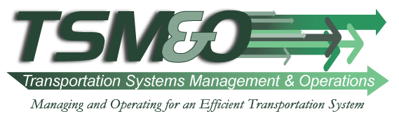
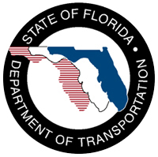
FDOT Internship Report

Eileen Cabrera
Florida International University

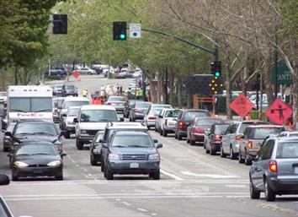
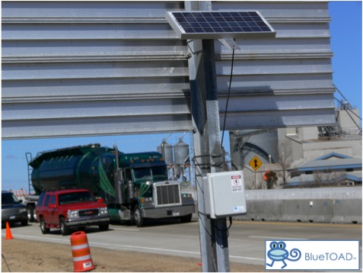
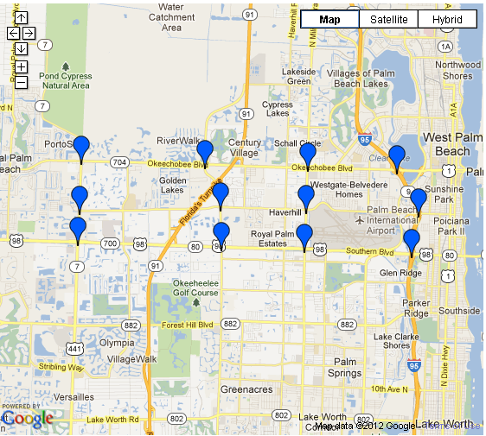
My name is Eileen Cabrera. I am a graduate student pursuing a master’s degree in Transportation Engineering at Florida International University (FIU). I have been at FIU since my freshman year where I obtained my Bachelor of Science in Civil Engineering in December 2011. I decided to continue with graduate school the next semester. During my summer internship at FDOT District IV, I worked under the supervision of Melissa Ackert, Transportation System Management and Operation (TSM&O) Program Manager within the Traffic Operations Office.

TSM&O is a fairly new program at FDOT based on measuring performance, actively managing the multimodal transportation network and delivering positive safety and mobility outcomes to the traveling public. Within TSM&O, I have learned the shift FDOT is undergoing from measuring transportation system outputs to presently measuring mobility outcomes, such as travel time reliability. The purpose of this shift is to maximize efficiency of the transportation system. When I started studying Transportation Engineering I believed I would be studying the traditional mobility improvement strategies, e.g., adding more lane miles. However, being involved with TSM&O has shifted my interest into their performance driven approach for solving congestion and traffic problems in which Intelligent Transportation Systems (ITS), signal system control, and other management and operational strategies are used to locate and correct the causes of congestion in real-time and improve travel time reliability.

My role this summer was to assist with the objectives of the TSM&O program. The main objective District 4 is working towards is monitoring and managing arterials. District 4 intends to bring Intelligent Transportation Systems (ITS), currently used along the interstates, to help monitor and improve the operations of the Arterial road system. The Advanced Transportation Monitoring System (ATMS) is the system being used to achieve these goals. ATMS projects are currently being deployed in the central Broward area, and being planned in Hallandale Beach Blvd and Hollywood Blvd.

By reviewing the contract documents, technical specifications, and submittals for the ATMS project in Central Broward, I became familiar with the objectives of this project. This project is being developed through a partnership between FDOT District 4, Broward County Traffic Engineering Department (BCTED), and Broward County Transit (BCT).The main purpose of this project is to combine ITS, Public Transit, Freeway and Arterial Traffic Operations into a single purpose of improving the operations and management of transportation in that area. I was exposed to some of the major system components of the projects such as Fiber optic cabling that is being linked from Broward Blvd to the tri-rail station to establish communication with AVL systems. Other components include Microwave Vehicle Detection System, Arterial Digital Message Signs for posting incident and travel time and incident information, Closed Circuit Television (CCTV) cameras for surveillance of the project area, and Real-time passenger advisory signs at bus stop locations that provide transit arrival and departure times at bus and tri-rail stations to further encourage ridership.

Other tasks I was involved in with the ATMS in Central Broward project included reviewing CCTV footage, preparing informational brochures, meeting agendas, and assisting with the budget. By reviewing CCTV footage provided by the contractor, I learned information about the operations of the cameras, such as radiuses and angles. While reviewing the footage, I had to verify that all specifications were met according to the ITS plan sheets. This task gave me the opportunity to better understand such plan sheets. While assisting with the budget, I was exposed to quantity take off and estimation for Arterial Digital Message Signs, Bluetooth devices, CCTVs, HUB/ core switches, Fiber optic cables, and Microwave Vehicle Detector Systems. One interesting topic I learned with this project was the accident response system being planned for Broward County. It was a description of possible operational scenarios that illustrated the uses of the TSM&O system and how the various agencies (FDOT District 4, BCTED, Broward Sheriff’s Office, BCT, FDOT 511, Road Rangers, Fire/ Rescue team, and Emergency Medical Services) will interface with it and the expected outcomes.

Throughout my internship at FDOT, my major task was to prepare a report and data analysis of a travel time study in an arterial network within Palm Beach County. Data was collected on seven congested arterials in Palm Beach County using twelve Bluetooth devices. The data collected included travel times and speeds. I was responsible for analyzing the data collected to drive performance measures that would begin arterial tracking, identify traffic trends, and assist FDOT in understanding the casual relationship between resources allocated to specific TSM&O activities and resulting outcomes. My results and report will be used for future reference to better operate and manage arterials through Palm Beach County’s ATMS.

The main focus of my report was to perform an analysis on the Palm Beach County’s network with five main objectives to satisfy the requirements of TSM&O. The main objectives of the project were to:

- Evaluate measurements of central tendency (mean, median, and mode) and measurements of variability (standard deviation and variance) for each segment to provide information to compare center values of current travel times to future after studies of the arterials.
- Analyze and graph the worst 5%, 10%, 15% Travel Times. The best and worst 5%, 10% & 15% travel times were graphed to compare the data’s trend to the average trend. 95%, 90% & 85% travel time bounds were also identified in this analysis. Average Delay was from the variation between the 5%, 10% & 15% trends and the average.

- Estimate average delay for each arterial.

- Compare mean travel times and speed during AM peak, Mid-day and PM peak. The corridor’s performance was measures by comparing average travel times and average speeds for each day and all peak periods.

- Identify 95% confidence bounds to determine Travel Time and Speed Reliability that will measure the consistency and dependability of travel time and speed along the arterials in Palm Beach County.

- Determine Travel Time Index and Buffer index for all peak periods to report a qualitative measure of the variability or uncertainty in the performance of each arterial. The goal is to achieve peak period travel time reliability on critical arterial segments in the network over time.
- Perform an Origin-Destination analysis to Measure cut-through traffic to determine travel times and major flows of traffic through areas along the network in Palm Beach County.

Furthermore, during my internship, I had to study Adaptive Traffic Control Systems which analyze real-time traffic data from vehicle detectors based on the current traffic conditions, demand, and system capacity. I worked on putting together a proposal to deploy Adaptive Systems in District 4 to handle daily and weekly fluctuations in traffic flow within urban areas. Given that Advanced Traffic Management Systems (ATMS) are already being installed in the district and Adaptive Traffic Control Systems have the capability to work with Communications Infrastructure used by ATMS, deploying adaptive systems in the district was the next step forward for the TSM&O. During my research of the Adaptive systems I learned a lot about Potential outcomes and benefits to the community of deploying ATCS. Some of these benefits include:

- Improvements of travel time reliability.
- Lowering of congestion and delay.
- Prolongation of the effectiveness of traffic signal timings and the reduction of public complaints.
- Reduction rear-ends crash rates.
- Response to day-to-day and TOD fluctuations in demand.
- Lower cycle for light traffic demand.
- Coordination between signals, handling special events changes in traffic volumes and patterns, and tourist area traffic.
- Maximization of throughput
- Delivery of network control.
- Prioritization of public transport.
- Decrease in emissions of hydrocarbons and carbon monoxide due to improved traffic flow.
- Reduction in the extent of oversaturation periods.
- Fuel consumption benefits.
- Reduction in air-pollution.
- Decreased time to develop signal timings.

To be able to prepare this proposal, I also had to learn about the system requirements such as vehicle detectors, management information bases, traffic controllers, hardware and software. One major task of this proposal was to come up with a budget estimate for the desire intersections. The total cost came up to $386,000. Therefore, other options had to be explored.

The most memorable experience with FDOT was having the opportunity to attend to a Broward County Metropolitan Planning Organization Technical Coordinating Committee meeting where my supervisor had a presentation on TSM&O. During this meeting I learned a lot about the Broward County Transportation Improvement Program (TIP). The TIP lists roadway, bikeway and pedestrian, and Transportation System Management projects. It was very interesting to learn about the upcoming transportation projects.

There were some motivating presentations during the Technical Coordinating Committee meeting that caught my attention. One of them was a presentation on Broward Complete streets guidelines by Smart Growth. Complete street guidelines are intended to encourage healthy living through the provision of a balance of transit, bicycle, and pedestrian facilities for all roadway users. I find it important that transportation engineers are trying to encourage the public to live a healthier life. Other informative presentations I learned from include: improvements to local roads such as State Road 7 and Oakland Park Blvd, and Broward County’s Transit future plans.

My internship at FDOT has been a remarkable experience. I have had the opportunity to enhance my education and technical experience. Working for FDOT was motivating and made me become more enthusiastic with my career. Melissa Ackert was an inspirational supervisor. Learning about TSM&O and ITS helped me look into the future of transportation engineering and shifted my career interest. I am very thankful I was able to experience this opportunity.

