[Report Title]

Contract # DTRT12GUTC12 with USDOT Office of the Assistant Secretary for Research and Technology (OST-R)

Final Report
[Date]

Principal Investigator: [ ]

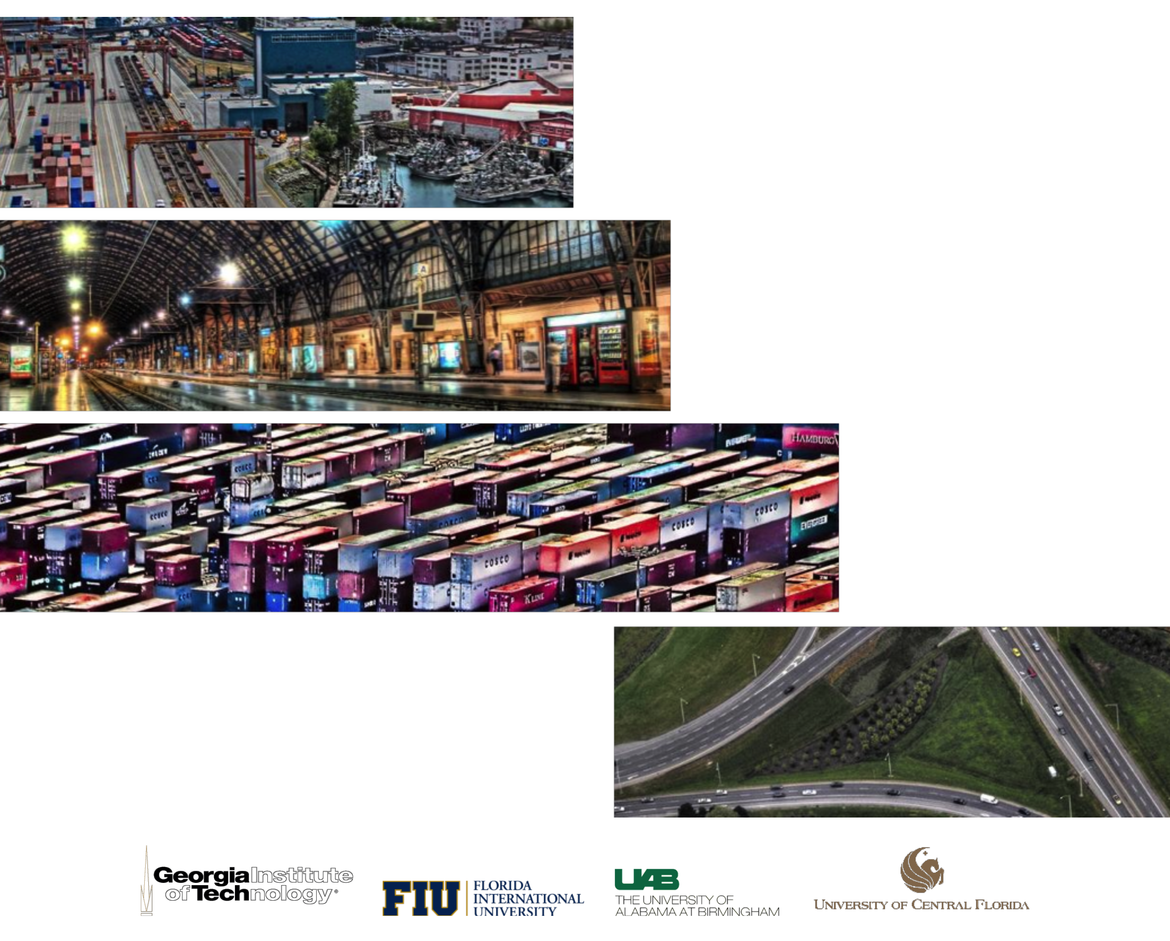

National Center for Transportation Systems
Productivity and Management
O. Lamar Allen Sustainable Education Building
788 Atlantic Drive, Atlanta, GA 30332-0355
P: 404-894-2236 F: 404-894-2278
nctspm@ce.gatech.edu nctspm.gatech.edu

